API basics

What is an API?
An API – application programming interface – at its most basic level, allows your product or service to talk to other products or services. In this way, an API allows you to open up data and functionality to other developers and to other businesses. It is increasingly the way in which agencies and companies exchange data and services, both internally and externally.

What are APIs used for?
APIs are launched primarily to give partners that are outside the agency or company “firewall” access to data and
resources. But recently, APIs are also being used by more and more of the general public, including non-developers. As APIs’ ease-of-use and popularity increases – and as APIs demonstrate their value and deliver efficiencies – many companies have begun to consume their own APIs to build internal systems, websites, and mobile apps using the same APIs that they make available to third-party developers and to the public.

Why do you need an API?
We want to make government more efficient; essentially do more with less. Government data assets are numerous and valuable, and we cannot afford to waste time and money by duplicating data processes. APIs allow for machine to machine querying, essentially removing the barriers to access data. APIs are not useful in all cases, but by providing data as a service, the opportunity for significantly reducing the barrier to access data and proliferate an innovation economy exists. Without them, we institute a culture of replicating data processes every time we use them.

How Does An API Work?
APIs communicate through a set of rules that define how computers, applications or machines can talk to each other. The API acts as a middleman between any two machines that want to connect with each other for a specified task.

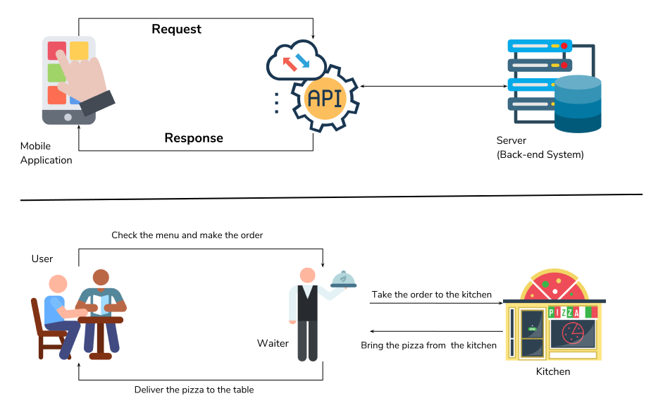
Refference :
1. https://api.mollybet.com/docs#create-a-new-account

2. https://stoplight.io/api-documentation-guide/basics/

